PROJECT PROPOSAL

NIHVA TECHNOLOGIES PVT. LTD.
187, G-Block, Thermax chowk, Above Renault Showroom, MIDC
Chinchwad, Pune – 411019.

Customer Name | L & T TECHNOLOGY SERVICES LIMITED
Office Address | 3rd Floor, Block – 3, Dlf It Park, Mount Poonamalle Road, Ramapuram
Project Location | Chennai
Contact Person Name | Mr. Ragupathi.m
Email Id | Ragupathi.M@LntTechservices.com
Contact Number | 96 8896 6960

Contact Person: Mr. Mayur Derle
Mob No.: 7709209333
Email id: automation@nihva.com
Web: http://www.nihva.com

AUTOMATION SOLUTION-DIVISION

Title: Portable Telescopic Conveyor with Counting System

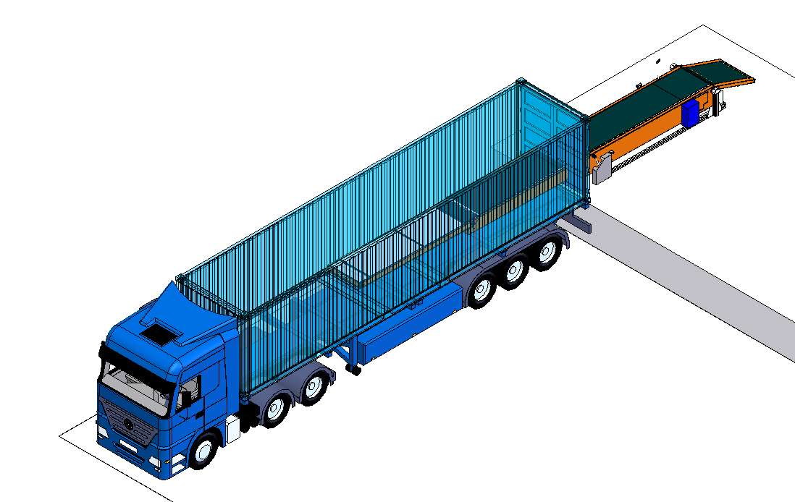
18’

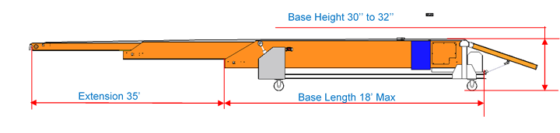

L & T Layout :

Conveyor usage area
Dock Platform
Dock Platform
Dock Platform
Dock Platform
Dock Platform
8.9’
2’
8.3’
14.6’
14.6’
4.8’
6.2’
7.2’
8.3’
8.3’
8.3’
8.3’
10.10’
8.11’
5’
18’
Server Room
1
2
3
4
5

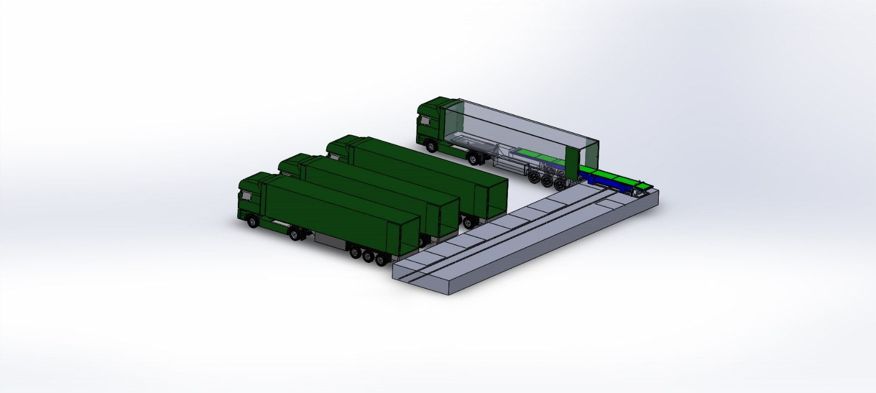

Telescopic conveyor arrangement as per above Layout

Date: 18/12/2017
Dear Sir,

Thank you for giving us an opportunity to participate with our offer on the above project. We enclose here with our proposal includes:

1.SCOPE OF SUPPLY
A. Telescopic Conveyor
  - Extended Length: 35 Feet
  - No of Section: 4
  - Base Length(Retract):18 feet Maximum
  - Belt Width: 1000mm
  - Conveyor Height: 30 inches
  - Unloading Height: 30 inches
  - Loading Height: 10 Inches to 48 inches
  - Adjustable up/down in loading & unloading by: Hydraulic
  - Extension & retraction by: Motorized
  - Movement of conveyor: One dock to another dock with less efforts.
B. Part Count sensor with Display
  - Sensor will count the number of bags loaded to truck from bay area and display it on the display system.
  - Display Unit will be at visible & legible position for loading person.
  - Inbuilt reset option.
  - Sensor will detect and count Overlap Bags and box.
  - Sensors & Display will be suitable for working in dust and dust accumulation environment.

C. IMAGES:
Telescopic Conveyor NIHVA
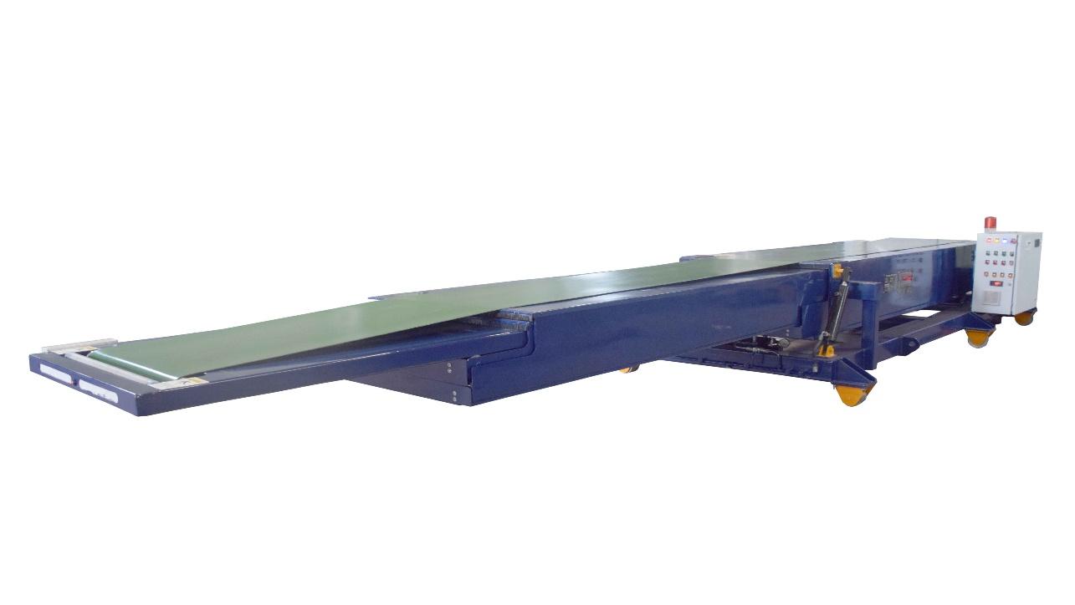

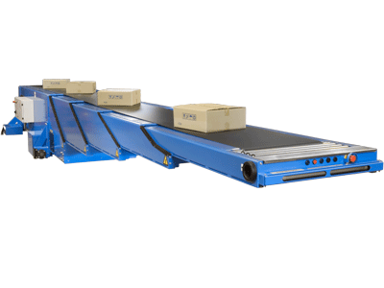
D. Techno – Commercial Offer

Sr no | Description | Qty | Unit | Rate in INR | Net Amount  INR
A | Telescopic Conveyor (Length -17 meters) with  C track | 1 | No | 17,64,000 | 17,64,000
B | Part Count Sensors with Display Panel | 1 | No | 1,50,000 | 1,50,000
C | Installation Charges & training for above System | 1 | No | 50,000 | 50,000
Total Cost of Project |  | 1 | Set |  | 19,64,000

GST PUNE: 27AAECN0437H1ZM | Amount in Words:  Rupees Nineteen Lacs Sixty-Four Thousand Only
HSN Code: 84289090
E. Technical Specification for Telescopic Conveyor & System:

Sr No | Description | Specifications
1 | Length of conveyor | 17000 mm
2 | Extended Length | 12000 mm
3 | Fixed Length | 5000 mm
4 | Width of conveyor | 1000 mm (as bag is 800mm)
5 | Material to be Convey | Gunny bags & cardboard
6 | Dimension of gunny bags 1 | 800(L) x 600(W) mm
7 | Dimension of gunny bags 2 | 600(L) x 600(W) mm
8 | Dimension of Cardboard Box | 600(L) x 280(W)x 330(H) mm
9 | Weight of bags & Cardboard | 6-30 kg s approximately
10 | Material of construction | Mild Steel
11 | Loading height from shop level | 1200 mm
12 | Speed of conveyor | 30 meter/min.
13 | Temperature | Ambient
14 | Drive motor | 5 HP Coupled geared motor
15 | Control Unit | PLC, Control Panel
16 | C track system | For manual movement
17 | Counter System | For counting no of bags & box
18 | Sensors | To detect, count bags & box
19 | 7 Segment Display | For display no of count
20 | Reset Switch | For Settings of conveyor

E. Drawings Training and warranty

Drawing:

We will issue a full set of drawings for approval within 2 weeks of receiving the confirmed order and finalized design details.

Training:

After installation of the Conveyor system, we will train the Clients personnel in the operation and basic maintenance, including the understanding of the error codes on the control system (if applicable).

Warranty:

- The warranty period is twelve months from the date of installation and commissioning.
- If a defect arises within the warranty period stated, which is attributable to faulty design,
- materials or installation workmanship the product will be repaired at our discretion without charge.

- This guarantee is subject to proper use of the product and assumes that the product is regularly serviced and maintained by skilled personnel in accordance with the operation and maintenance instructions supplied.

- Maintenance & Service Agreement:
We would suggest that you take advantage of a maintenance and service agreement on the NIHVA products, which will guarantee trouble free operation and speed of response in an emergency. Customized proposals are available on request.

We are pleased to inform that we also undertake AMC for all of our

products & for any of your existing facilities.

Maintenance and service aren’t about what you get. They’re about what

you avoid: failures, losses and unplanned interruptions.

- Client Scope:
- Civil work for C track / machineries/structural work required to support are in client scope.

- Unloading from truck placement on site.

- Exiting/Repair/ Modification/ Refurbishment charges will be extra.

G. Terms and Conditions: -

- Price : Ex. Works Pune

- P & F : 3 % Extra at the time of delivery.

- Freight Notes : Extra as applicable.

- Delivery : Within 9- 10 weeks from date of receipt of
confirmed purchase order, advance payment,
drawing approval.

- Payment Terms : 80% advance along with confirmed purchase
order balance before dispatch.

- Insurance : Extra as applicable.

- GST : 28% Applicable on total supply value.

- Validity : 15 days from date of quotation.

9.Warranty : 12 months from date of supply.

Please feel free to contact Mr. Mayur Derle on 7709209333 for any further clarification in this concern.

With Best Regards,
Pooja Badre
7709209333
For NIHVA Technologies Pvt Ltd

